**SUPERVISION**

**Date / time: 27/11/2025**

**Main issues discussed**

**1. You don’t need to worry too much about the word limit; if there is a good justification and the writing is strong, a longer length is acceptable.**

**2. The requirements and challenges of the Presentation (CW2).**

**3. Presentation arrangements with the second supervisor (Taylor Ring).**

**4. Use of Appendices and Online Resources**

**Work shown**

1. **Draft for energy consumption measurement.**

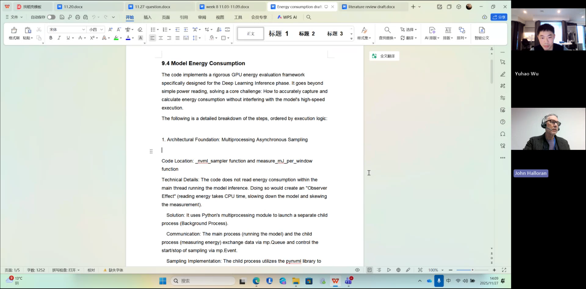

1. **Github code**

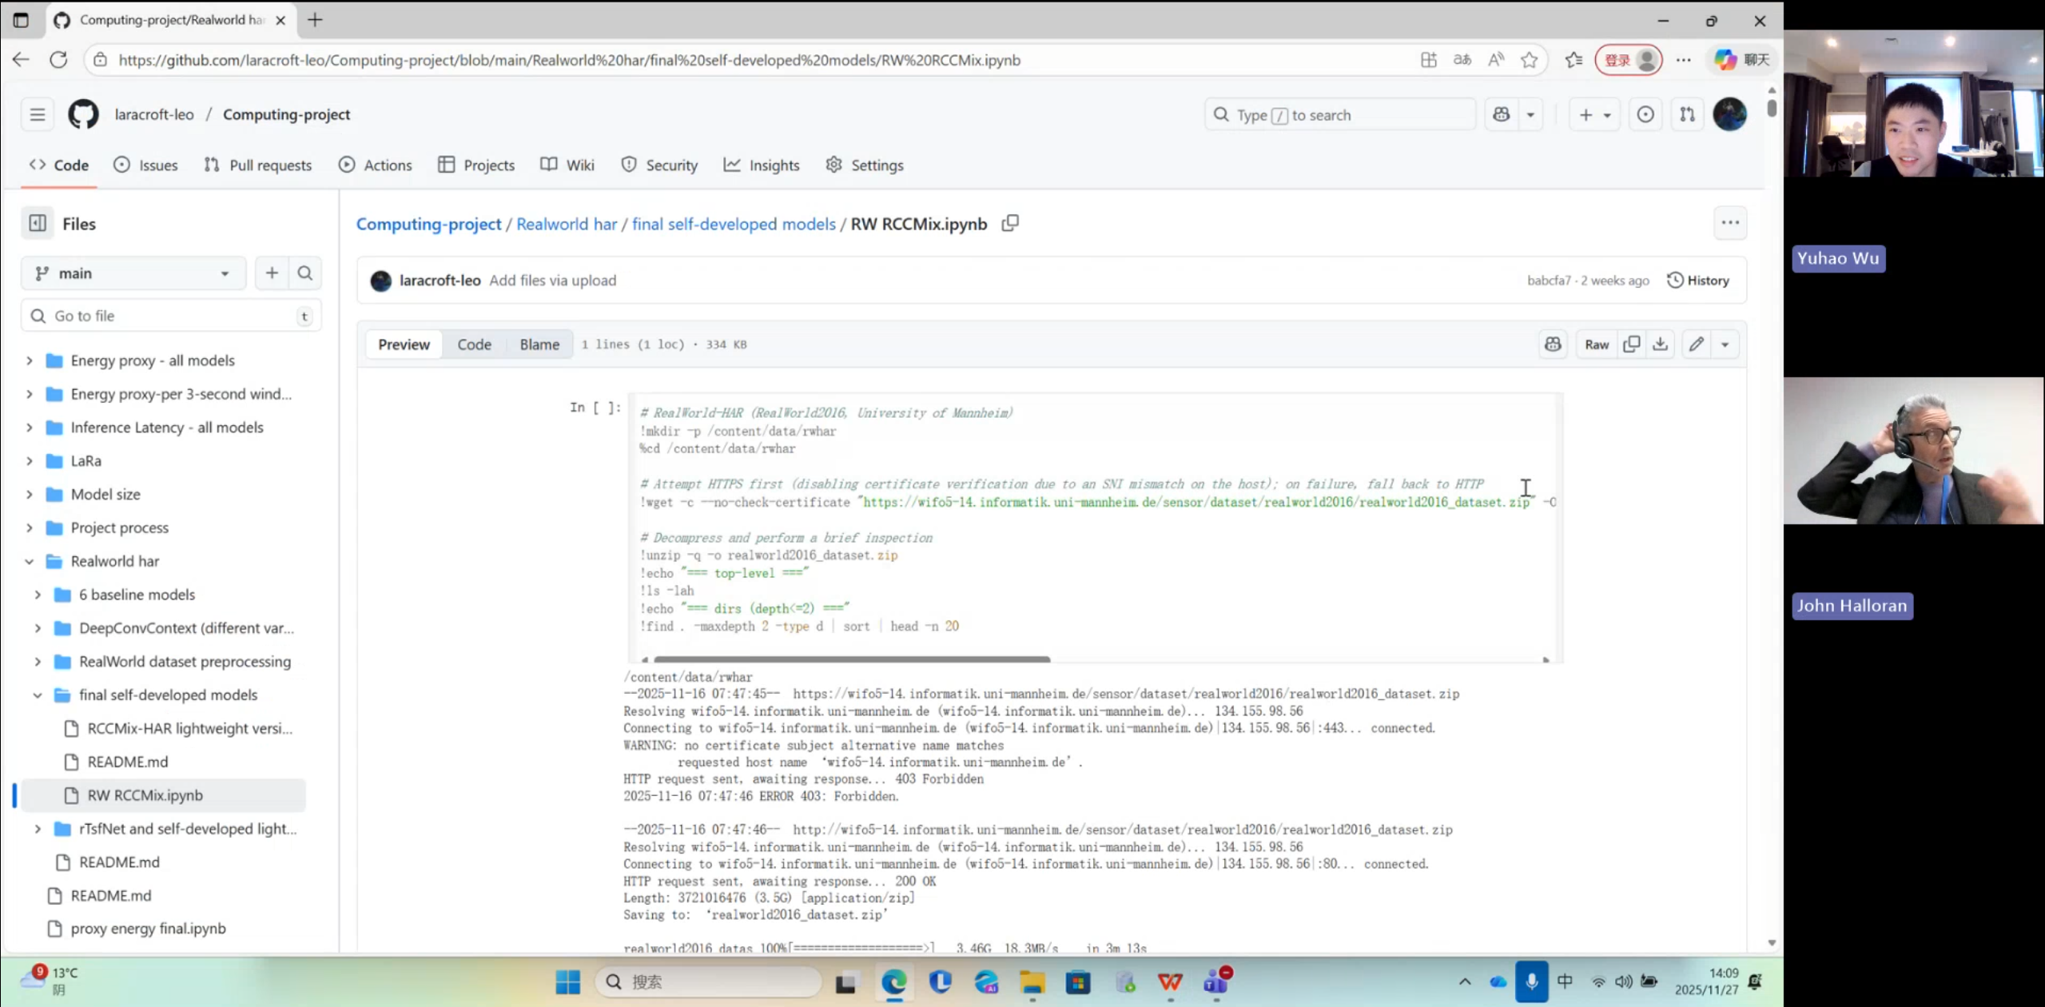

1. **Literature review**

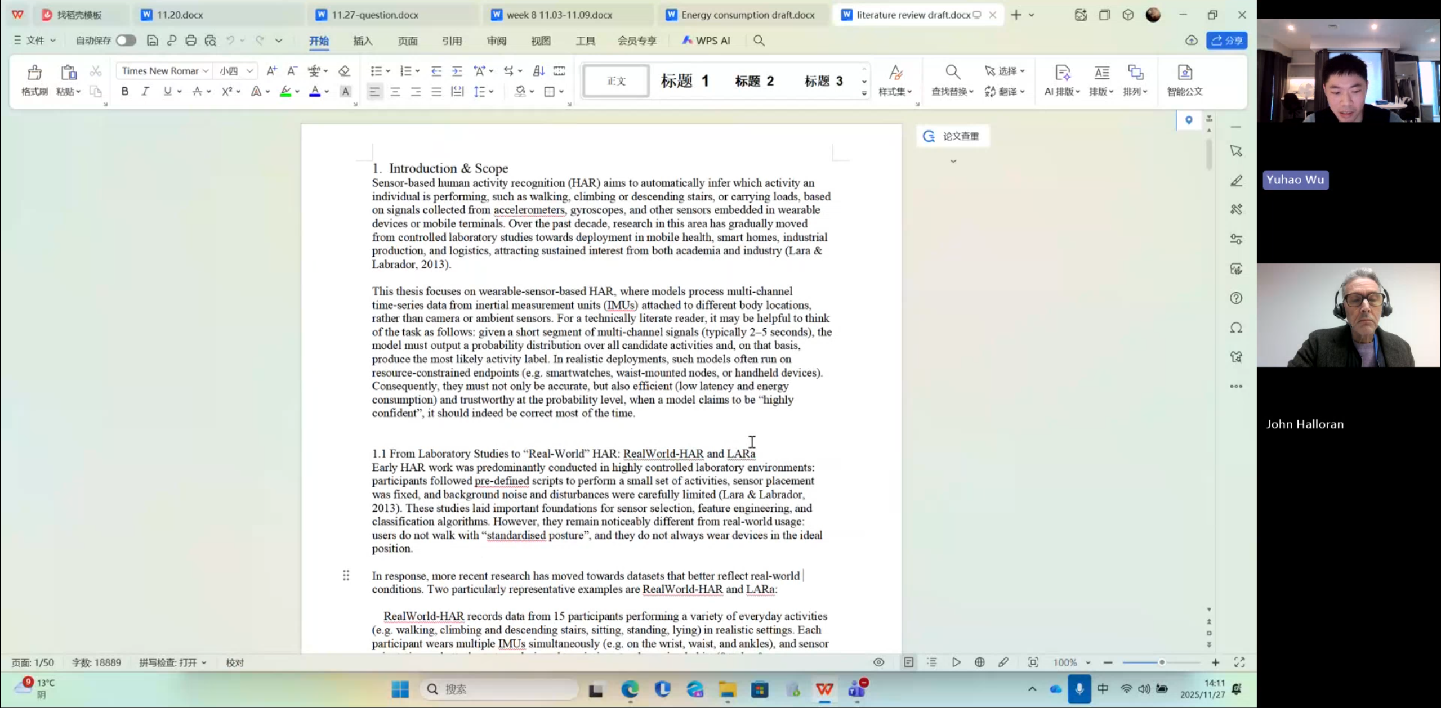

**Questions asked; how questions were answered**

**My dissertation is currently 50,000 words long; is that too much?**

**Answer**

**50,000 words is indeed “a lot”, but if you truly did a lot of work, a large word count is natural. The key question is why it has become so long. I need to take a look before I can give you feedback.**

**Email**

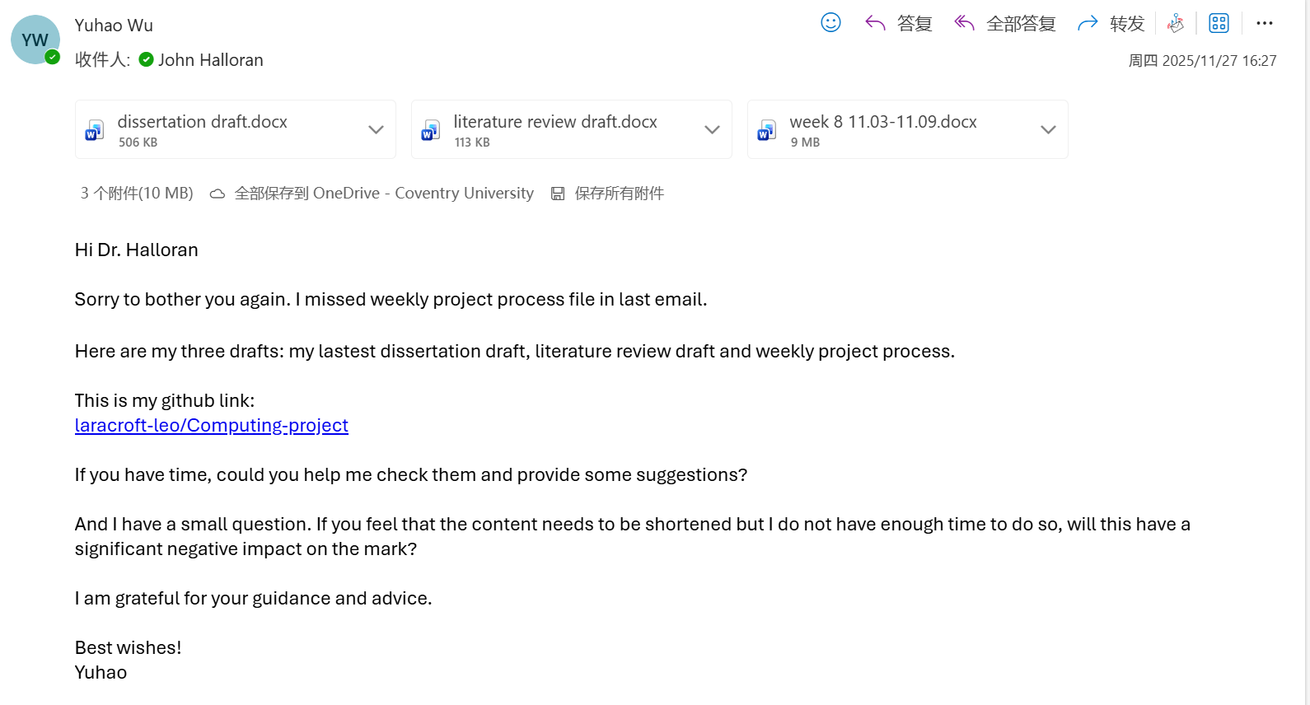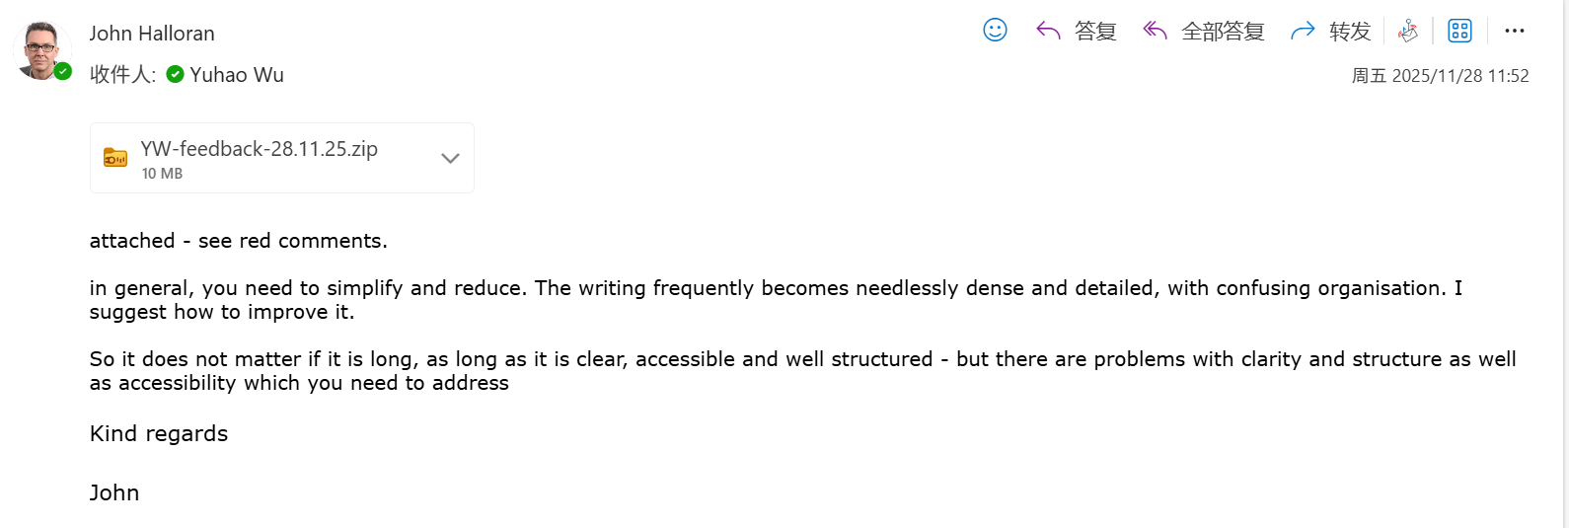

**Computing Project**

**WORK DONE**

1. **Literature review**
2. **Weekly project process**

**Issues and challenges**

**1. There are many problems with the literature review, such as the heading hierarchy and overall organisation.**

**2. The project process needs to be simplified.**

**3. The dissertation title is confusing, and some parts are not clear enough.**

**Actions for next week**

**Finish the dissertation and prepare the presentation.**

**Evidence**

<https://livecoventryac-my.sharepoint.com/:v:/g/personal/aa1910_coventry_ac_uk/EXkByoRGyFpOqghdie-7IxIBLbC-9lmeHS0uf1enw4pH9w>